Case 8-CAN-NW Coast-Mask-Shaman-White Hair-Red and Black Pigments-19th c

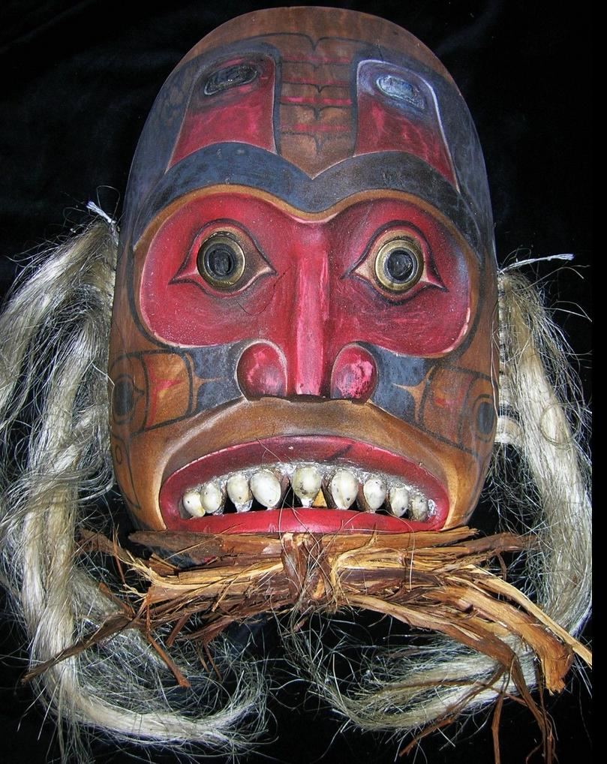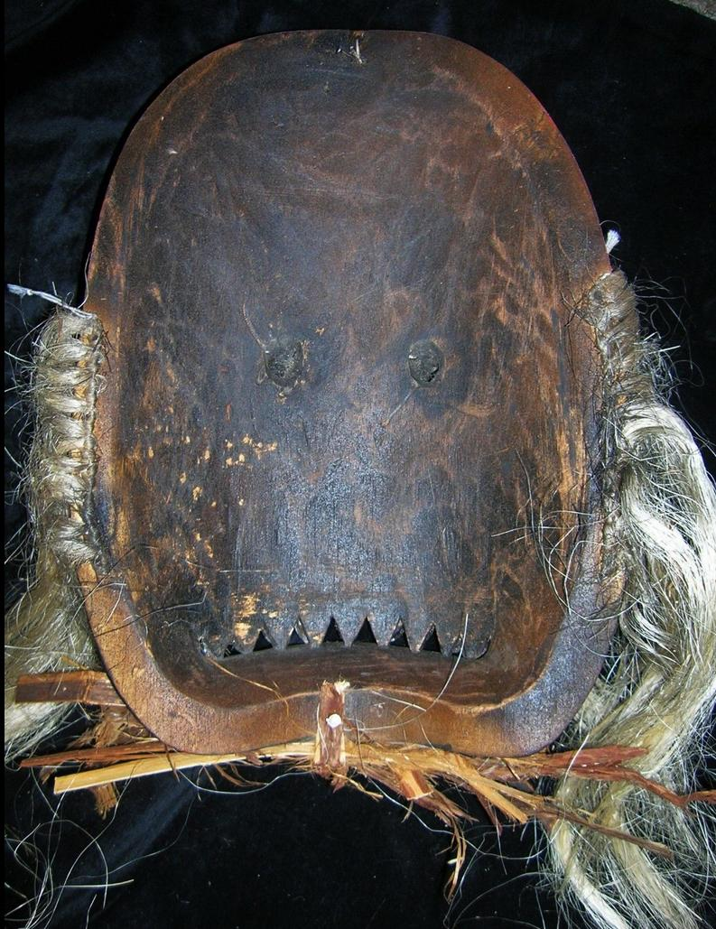

**Northwest coast shaman's mask.**

**Copper lower eyes and fish eyes of abalone shell, on forehead, operculum teeth, human hair. The two 2 sets of eyes to enhance the Shaman's perception are unique. Signed "Bear Thompson" Many years of shamanic use and wonderful patina. EX Robert Cornell estate in Ludlow MA**

Sold by [primitifstuff](http://myworld.ebay.com/primitifstuff) ( [1787](http://feedback.ebay.com/ws/eBayISAPI.dll?ViewFeedback&userid=primitifstuff) )

### Delivery package 1 of 1

Estimated delivery Thursday, Oct 8, 2015 - Monday, Oct 12, 2015

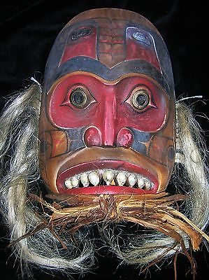

#### [NORTHWEST COAST SHAMAN MASK, OPERCULUM TEETH, SIGNED 16"](http://www.ebay.com/itm/221903668982)

|  |  |
| --- | --- |
| Item price | $199.99 |
| Quantity | 1 |
| Item number | 221903668982 |
| Shipping service | USPS Priority Mail |